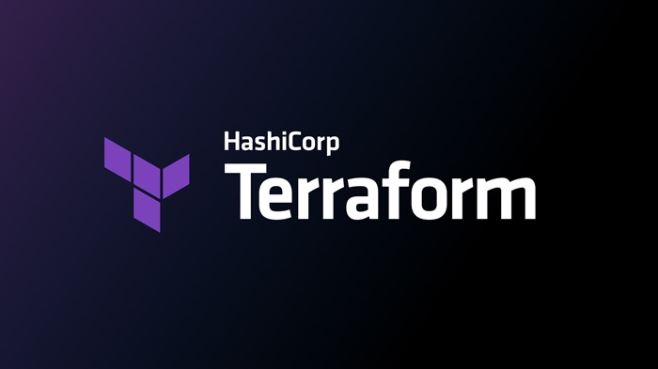
TERRAFORM 06
Execute the script shown in the video.
Terraform Modules:
Click on the option to create a directory in main workspace:
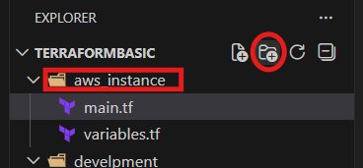
After that create 2 files naming main.tf and variable.tf
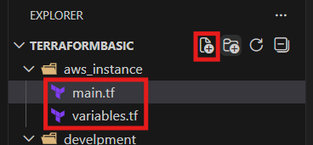
After that create another directory named development and create a single main.tf file no need of variable file
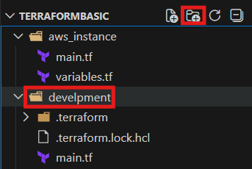
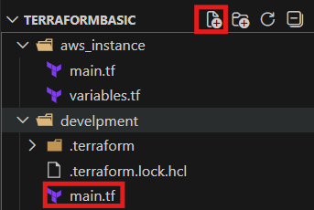
After that in the main.tf in aws_instance directory insert the script and save
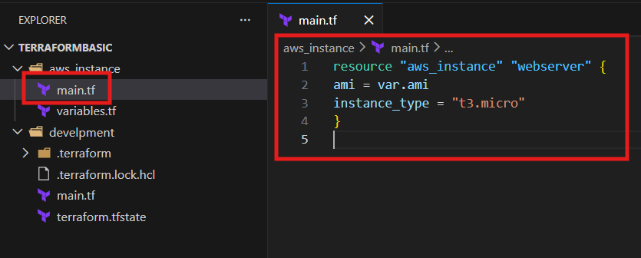
Syntax:
resource "aws_instance" "webserver" {
ami = var.ami
instance_type = "t3.micro"
}
And also insert the variabl.tf syntax also
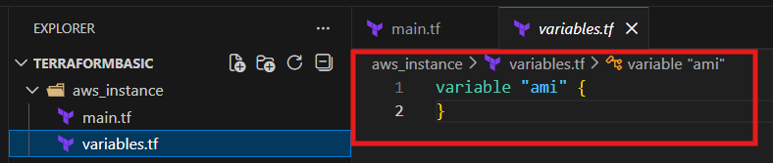
Syntax:
variable "ami" {
}
In the development main.tf file add the data like module and ami id
The source is that path of aws_instance directory
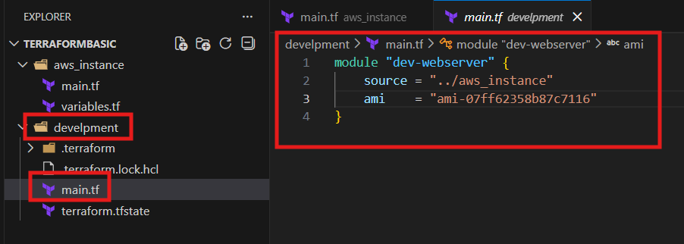
Syntax:
module "dev-webserver" {
source = "../aws_instance"
ami = "ami-07ff62358b87c7116"
}
Then
Change the directory to development in cli

Commands: terraform init and apply
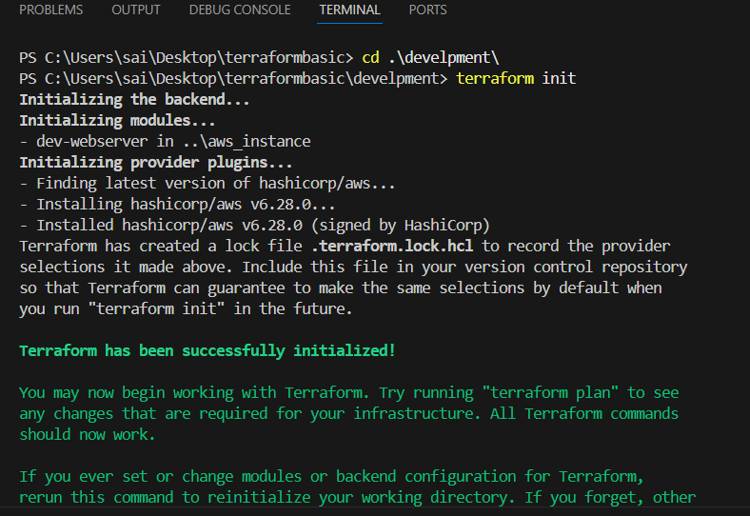
When we executing from development directory the details were fetching from root module is aws_instance and ec2 is launching
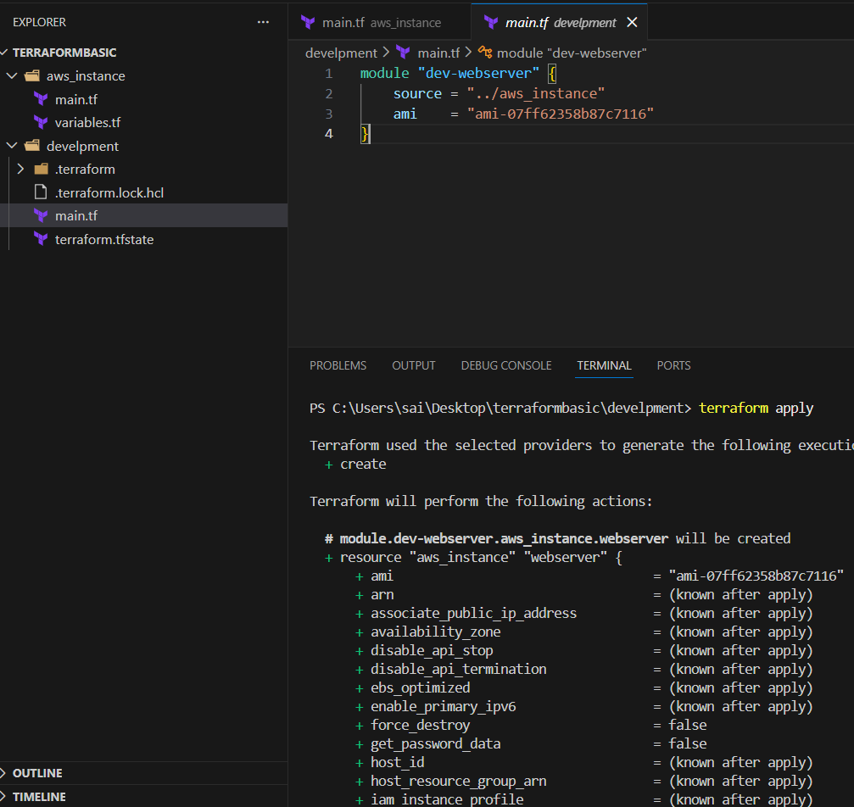
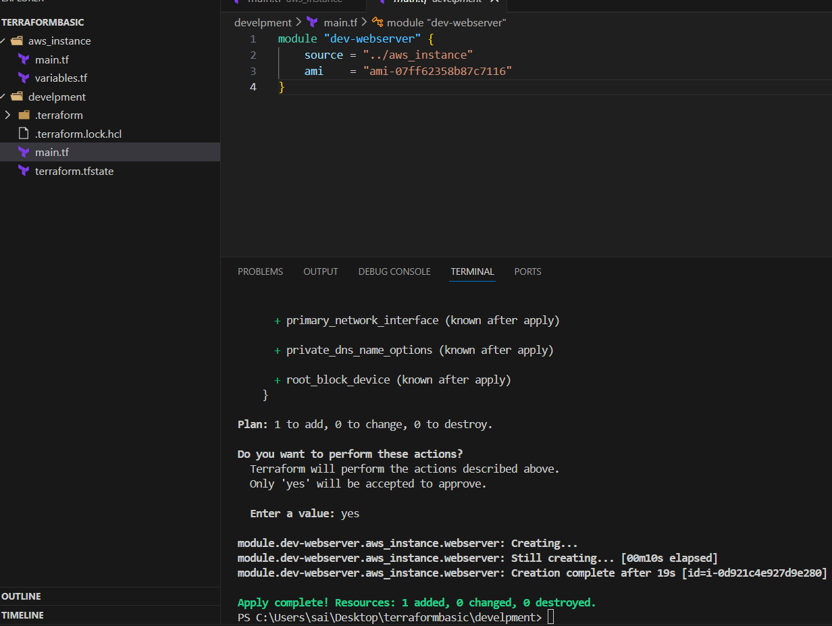
Validated in aws as new instance is created
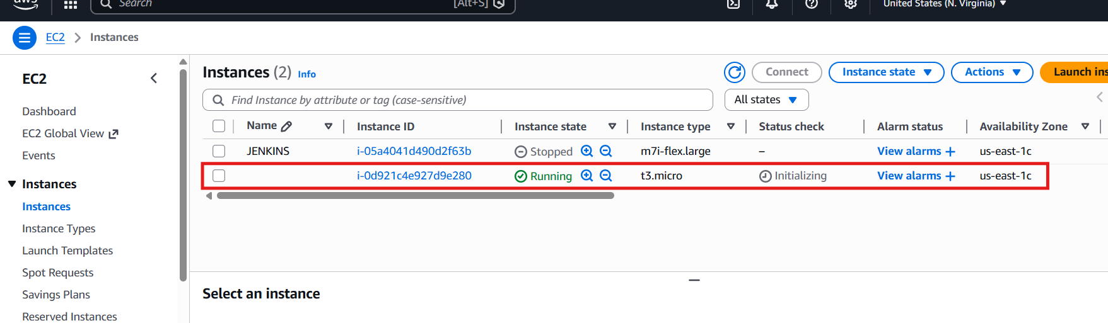

Terraform Workspaces:
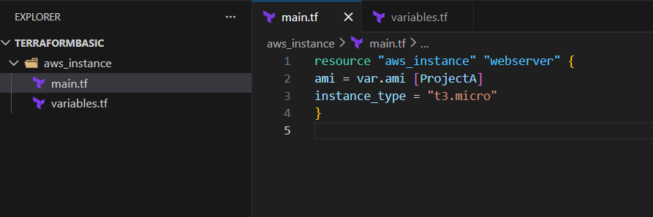
Syntax:
resource "aws_instance" "webserver" {
ami = var.ami["ProjectA"]
instance_type = "t3.micro"
}

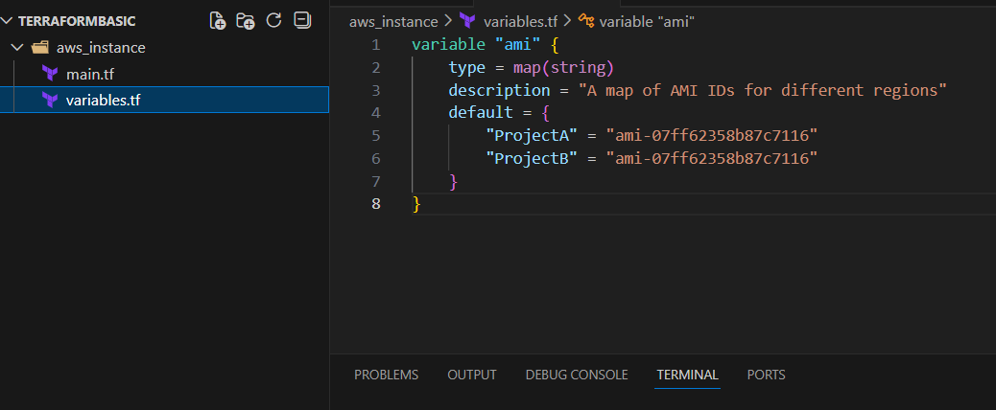
Syntax:
variable "ami" {
type = map(string)
description = "A map of AMI IDs for different regions"
default = {
"ProjectA" = "ami-07ff62358b87c7116"
"ProjectB" = "ami-07ff62358b87c7116"
}
}

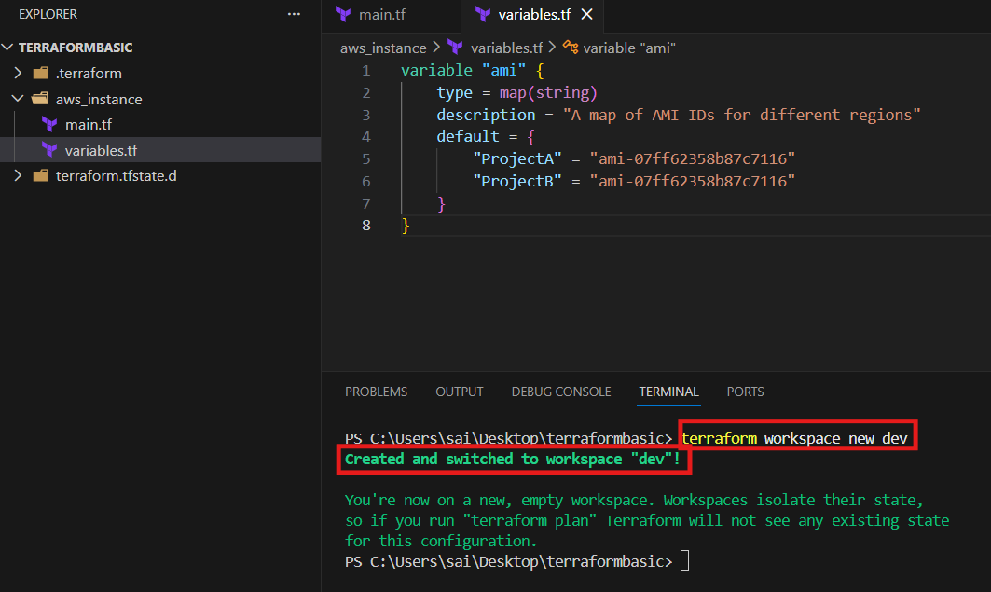
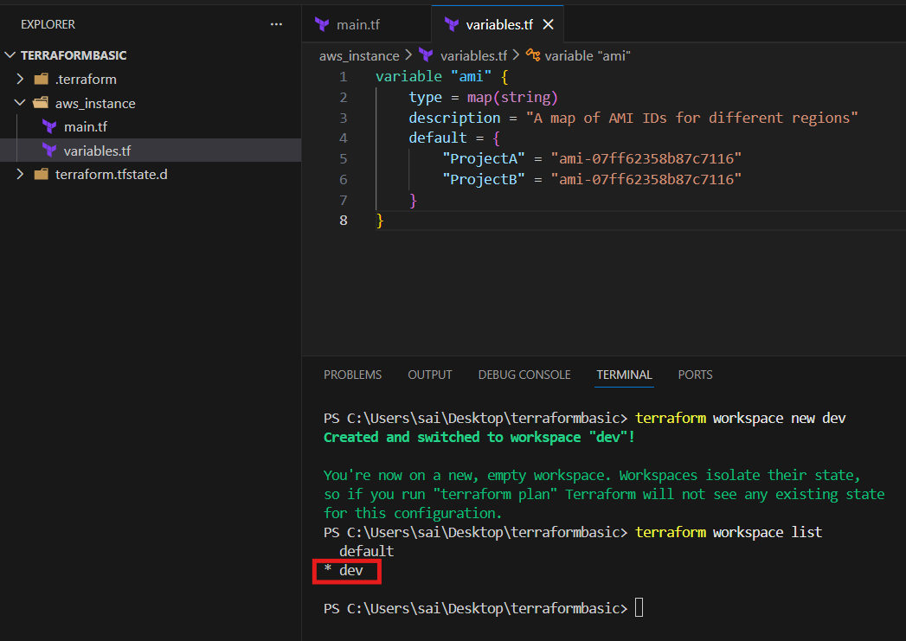
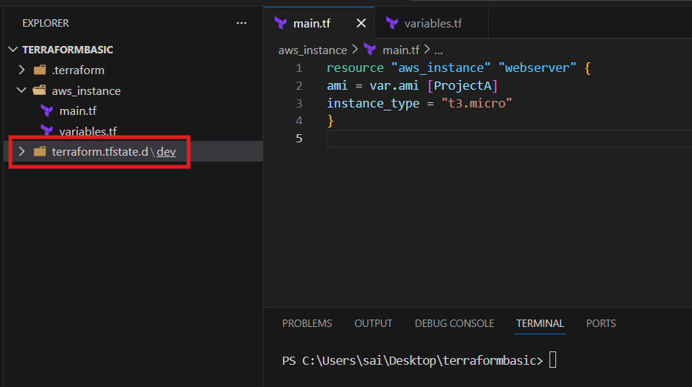

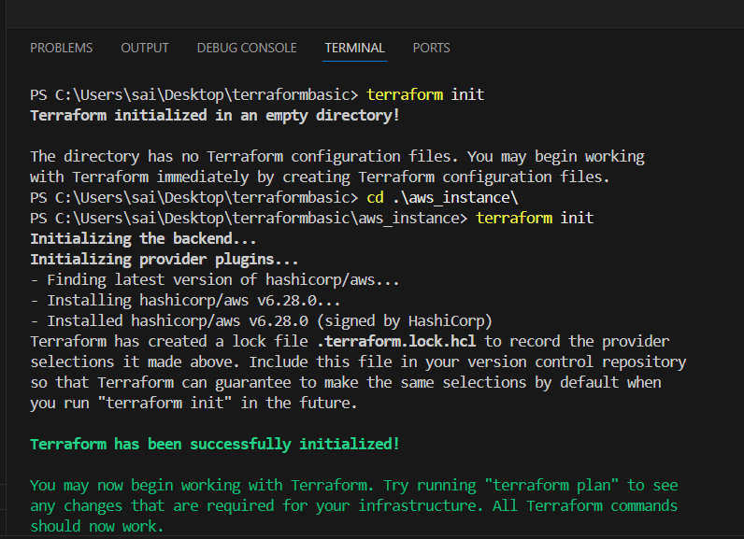
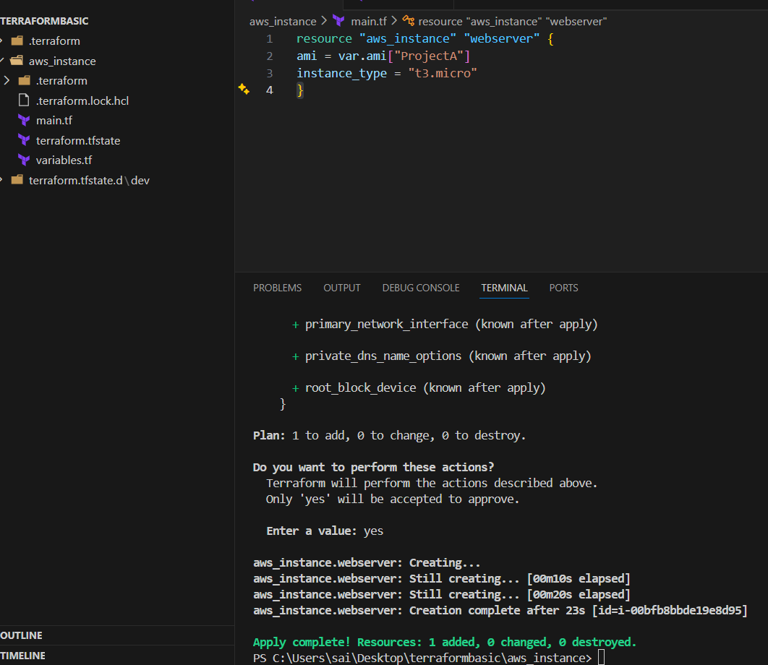
Validated in aws
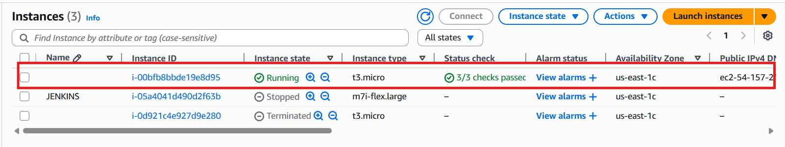

3.Provision EC2, S3, and VPC using Terraform modules.
Create a directory and main.tf file and paste the syntax
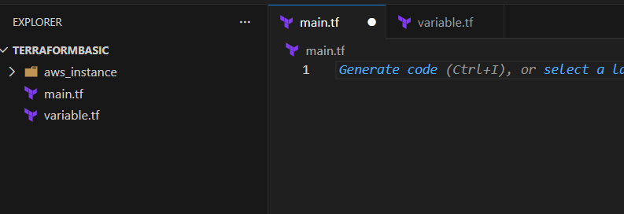
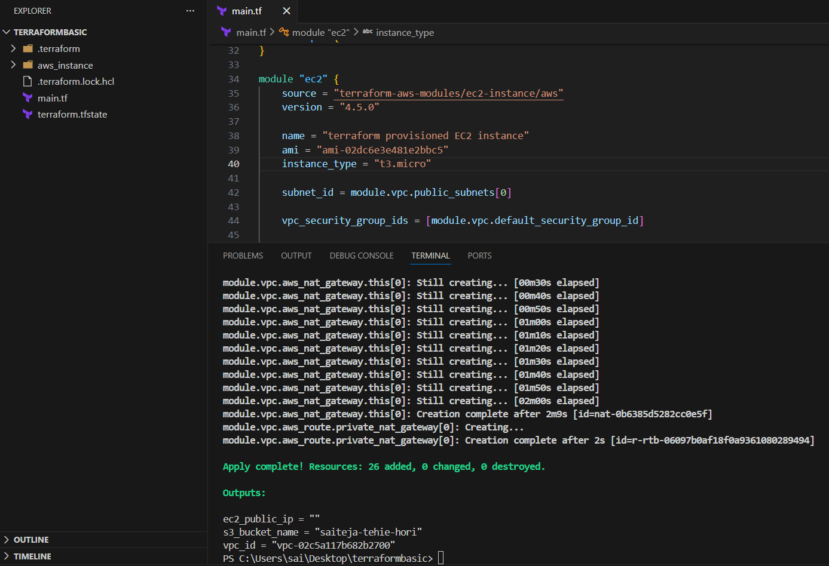

Note: I launched private instance with no public ip if you need public ip then I added line below subnet id
associate_public_ip_address = true

Syntax:
terraform {
required_version = ">= 1.3.0"

required_providers {
aws = {
source = "hashicorp/aws"
version = "~> 5.63"
}
}
}

provider "aws" {
region = "us-east-1"
}
module "vpc" {
source = "terraform-aws-modules/vpc/aws"
version = "5.1.2"
name = "my-vpc"
cidr = "192.168.0.0/20"
azs = ["us-east-1a", "us-east-1b", "us-east-1c"]
public_subnets = ["192.168.1.0/28", "192.168.2.0/28", "192.168.3.0/28"]
private_subnets = ["192.168.4.0/28", "192.168.5.0/28", "192.168.6.0/28"]

enable_dns_hostnames = true
enable_nat_gateway = true
single_nat_gateway = true

tags = {
Terraform = "true"
Environment = "dev"
}
}

module "ec2" {
source = "terraform-aws-modules/ec2-instance/aws"
version = "4.5.0"

name = "terraform provisioned EC2 instance"
ami = "ami-02dc6e3e481e2bbc5"
instance_type = "t3.micro"

subnet_id = module.vpc.public_subnets[0]
associate_public_ip_address = true

vpc_security_group_ids = [module.vpc.default_security_group_id]

tags = {
Terraform = "true"
Environment = "dev"
}

}

module "s3" {
source = "terraform-aws-modules/s3-bucket/aws"
version = "3.7.0"

bucket = "saiteja-tehie-hori"
tags = {
Terraform = "true"
Environment = "dev"
}

}

output "vpc_id" {
value = module.vpc.vpc_id

}
output "ec2_public_ip" {
value = module.ec2.public_ip
}
output "s3_bucket_name" {
value = module.s3.s3_bucket_id
}

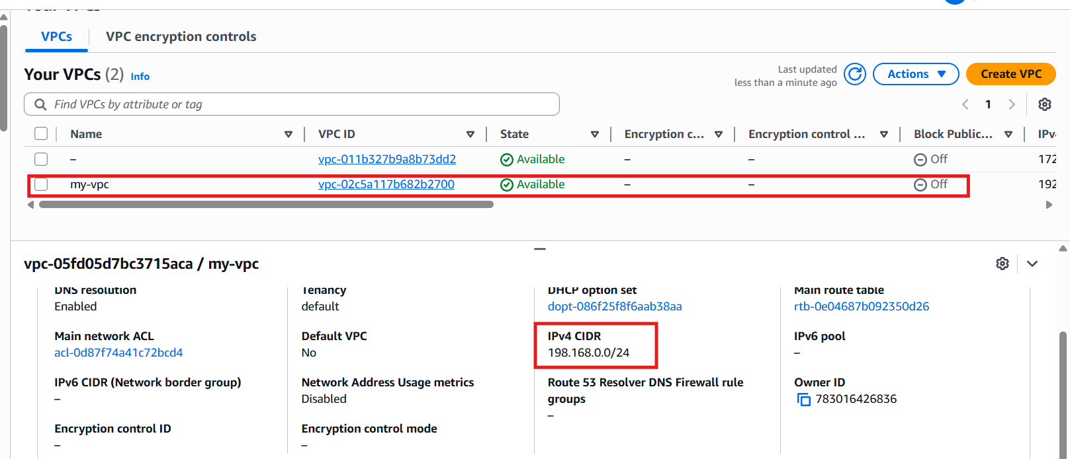
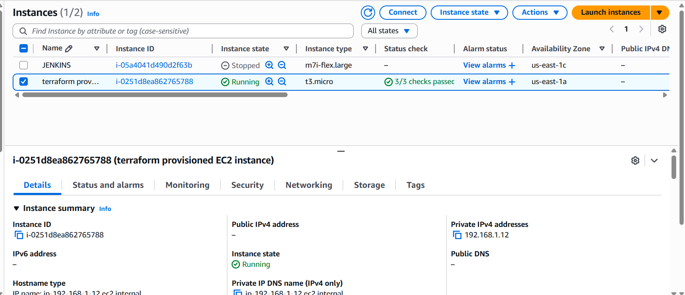
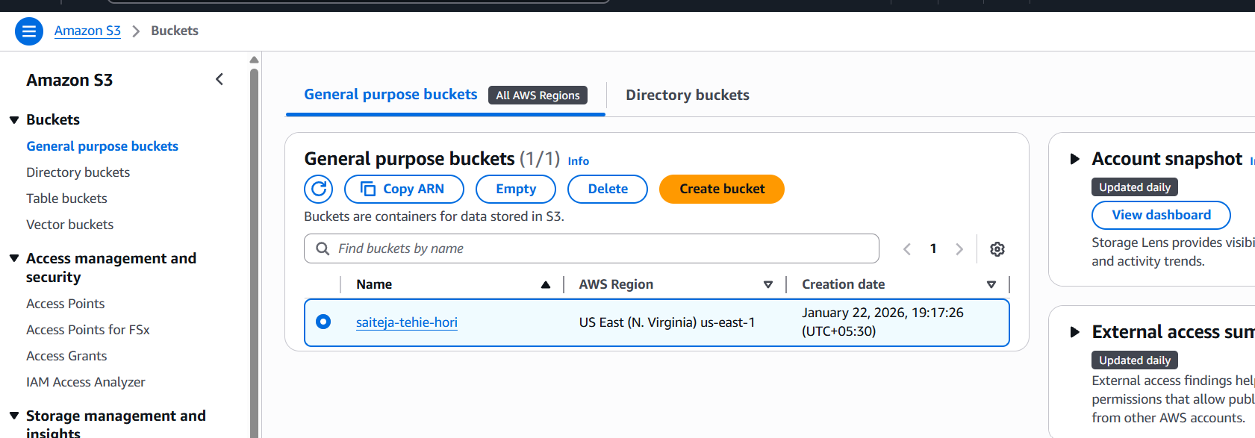

4.Provision EC2 for 3 different environments (Dev, Staging, and Prod) using Terraform workspaces.

Note:: change the region and ami as per your requirement
Syntax:
terraform {
required_version = ">= 1.3.0"
required_providers {
aws = {
source = "hashicorp/aws"
version = "~> 5.63"
}
}
}
provider "aws" {
region = "us-east-1"
}
locals {
env = terraform.workspace
instance_type_map = {
dev = "t3.micro"
staging = "t3.small"
prod = "t3.small"
}
instance_name_map = {
dev = "dev-ec2"
staging = "staging-ec2"
prod = "prod-ec2"
}
}
# Default VPC
data "aws_vpc" "default" {
default = true
}
# Default Subnet
data "aws_subnets" "default" {
filter {
name = "vpc-id"
values = [data.aws_vpc.default.id]
}
}
# Security Group
resource "aws_security_group" "sg" {
name = "${local.env}-sg"
description = "Security group for ${local.env} "
vpc_id = data.aws_vpc.default.id
tags = {
environment = local.env
}
}
# EC2 Instance
resource "aws_instance" "app" {
ami = "ami-07ff62358b87c7116"
instance_type = local.instance_type_map[local.env]
subnet_id = data.aws_subnets.default.ids[0]
vpc_security_group_ids = [aws_security_group.sg.id]
tags = {
Name = local.instance_name_map[local.env]
environment = local.env
}
}
output "environment" {
value = local.env
}
output "instance_type" {
value = aws_instance.app.instance_type
}
output "public_ip" {
value = aws_instance.app.public_ip
}

Execute terraform init it will download all the dependencies and resources
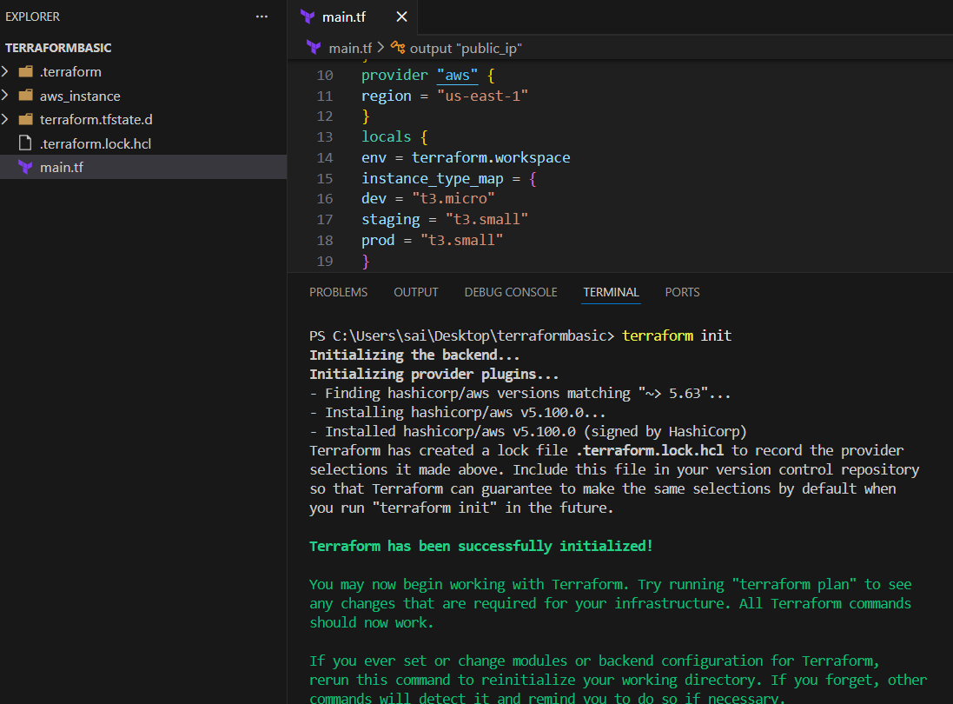

I executed apply but got an error because I didn’t created any work space so that I resolved the issue by creating a workspace using the command
Terraform workspace new dev
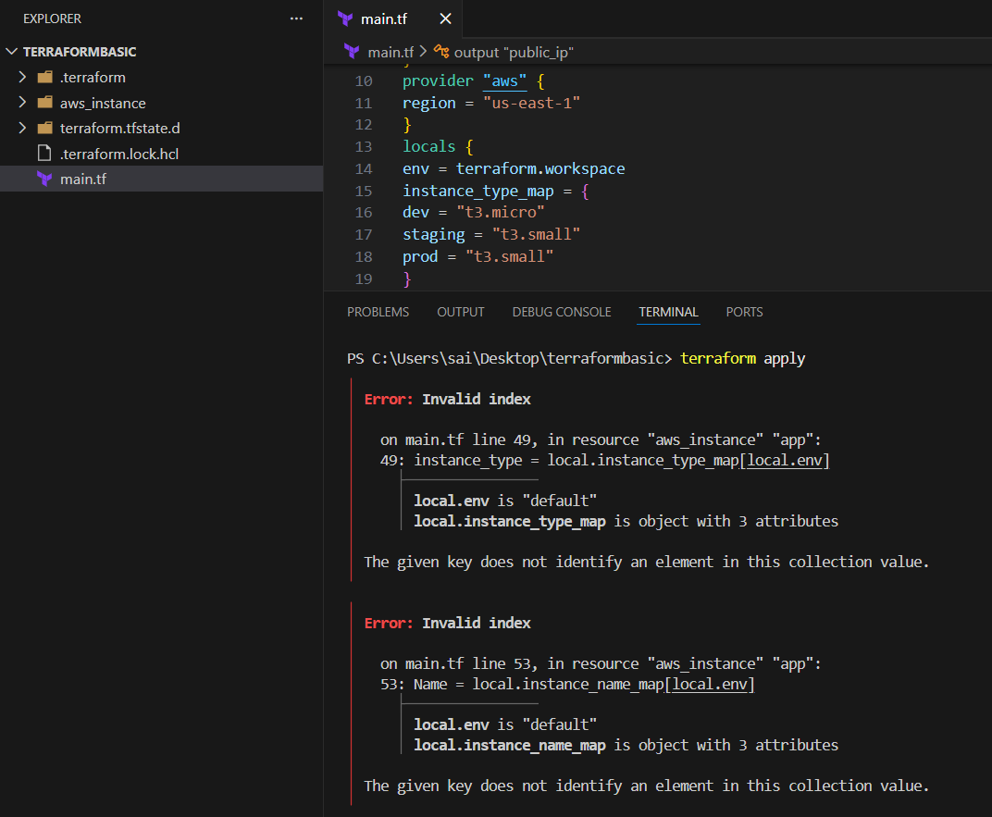

After creating it automatically changes the workspace else you can change manually by
Terraform workspace select dev command
After that execute terraform apply command it will provision the infrastructure for dev environment
Do the same for all environments
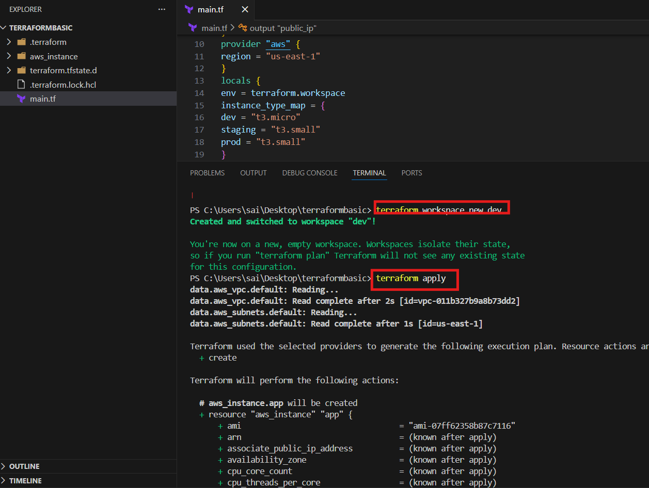

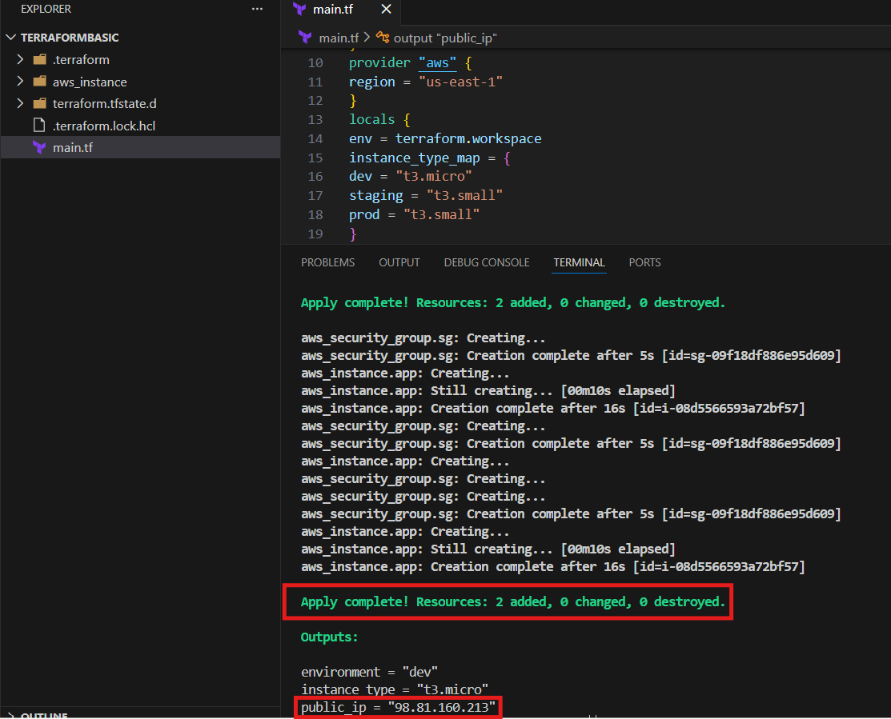
Specific env instance has been created
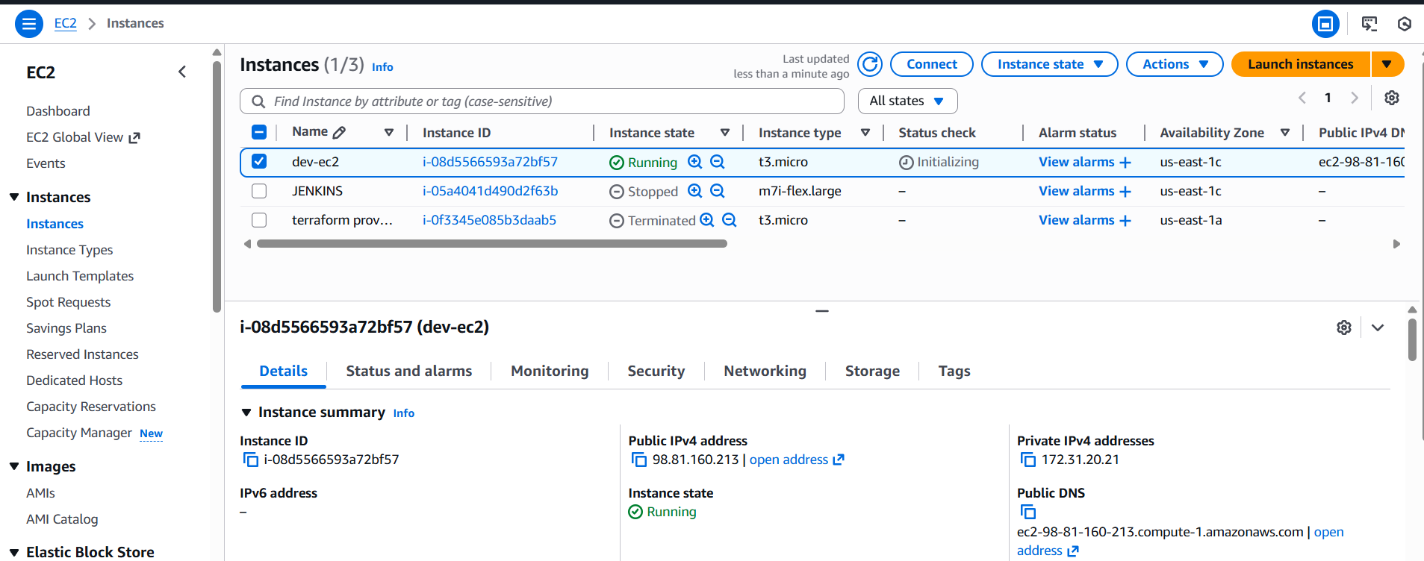

For other environments do the same create work spaces and apply
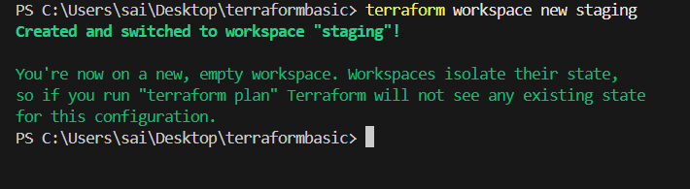
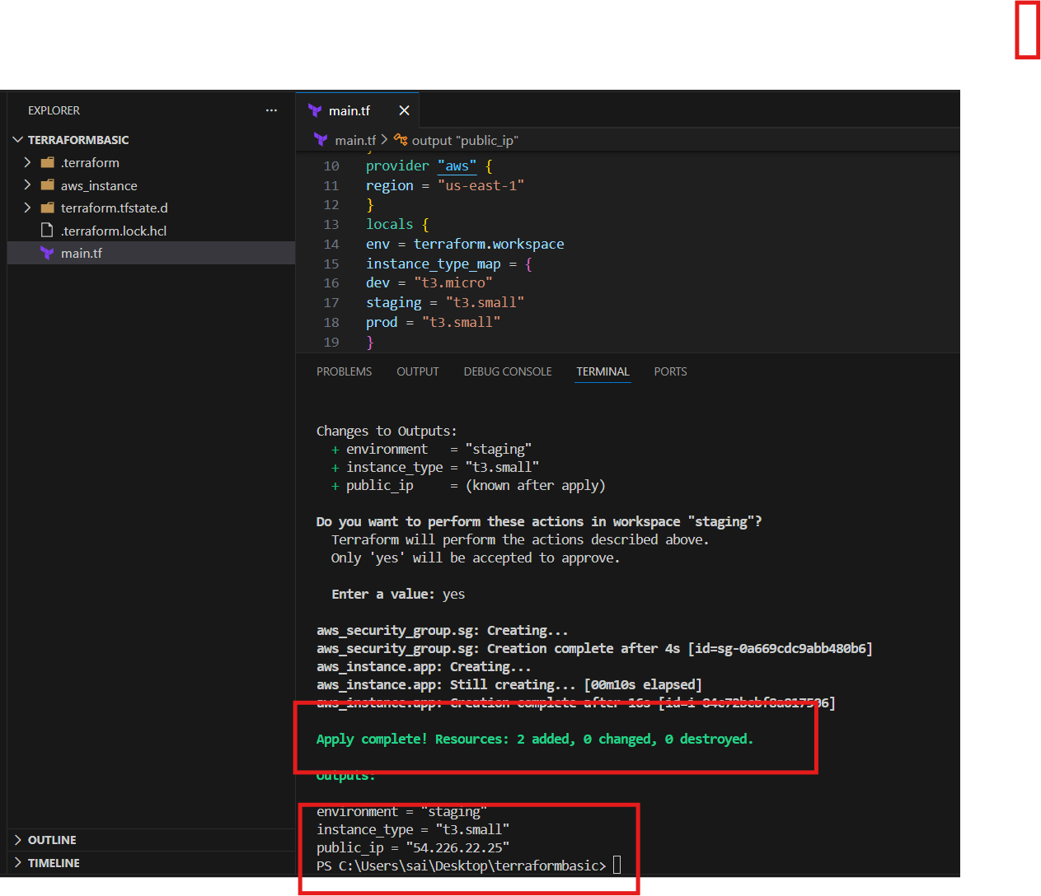
Validated in aws
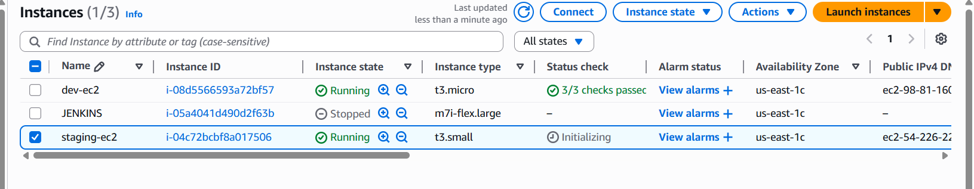
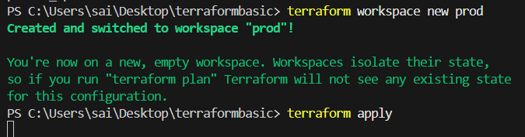
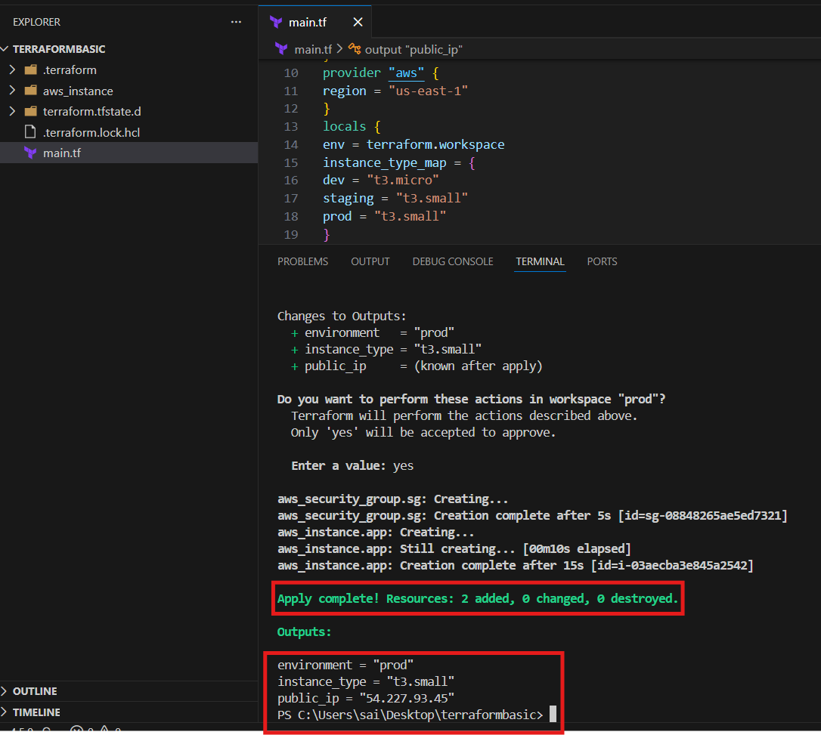
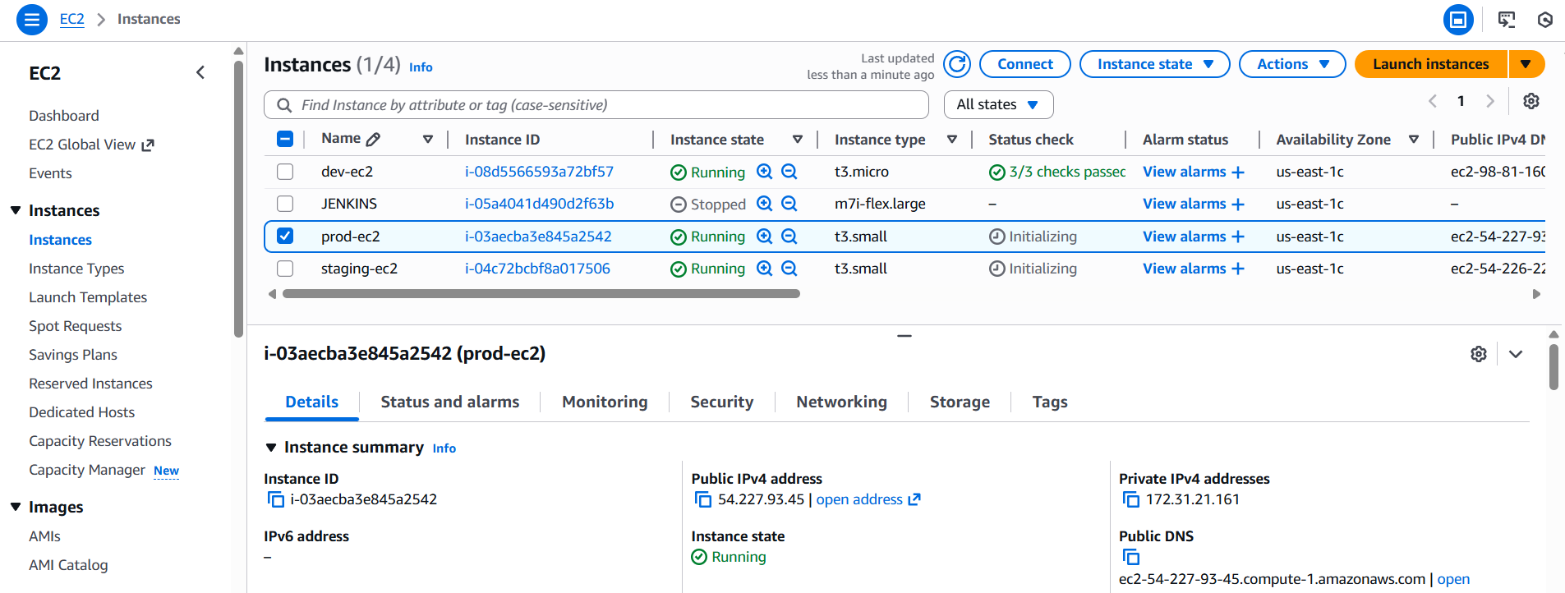
After creating 3 stages the instances were in below image
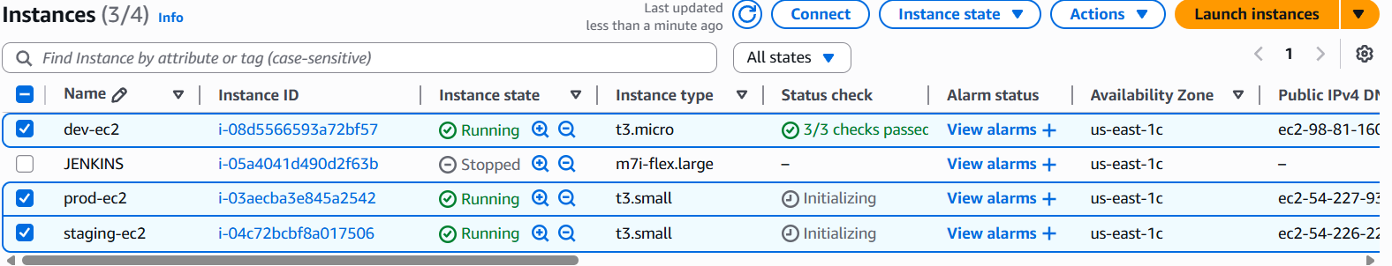
The below commands helps us to list and show the workspaces
And * indicates in which workspace we are
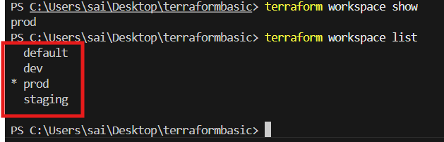

While executing destroy command the particular work space infrastructure will be deleted not all
Change the workspace and delete each env
Command::
Terraform workspace select <env name>
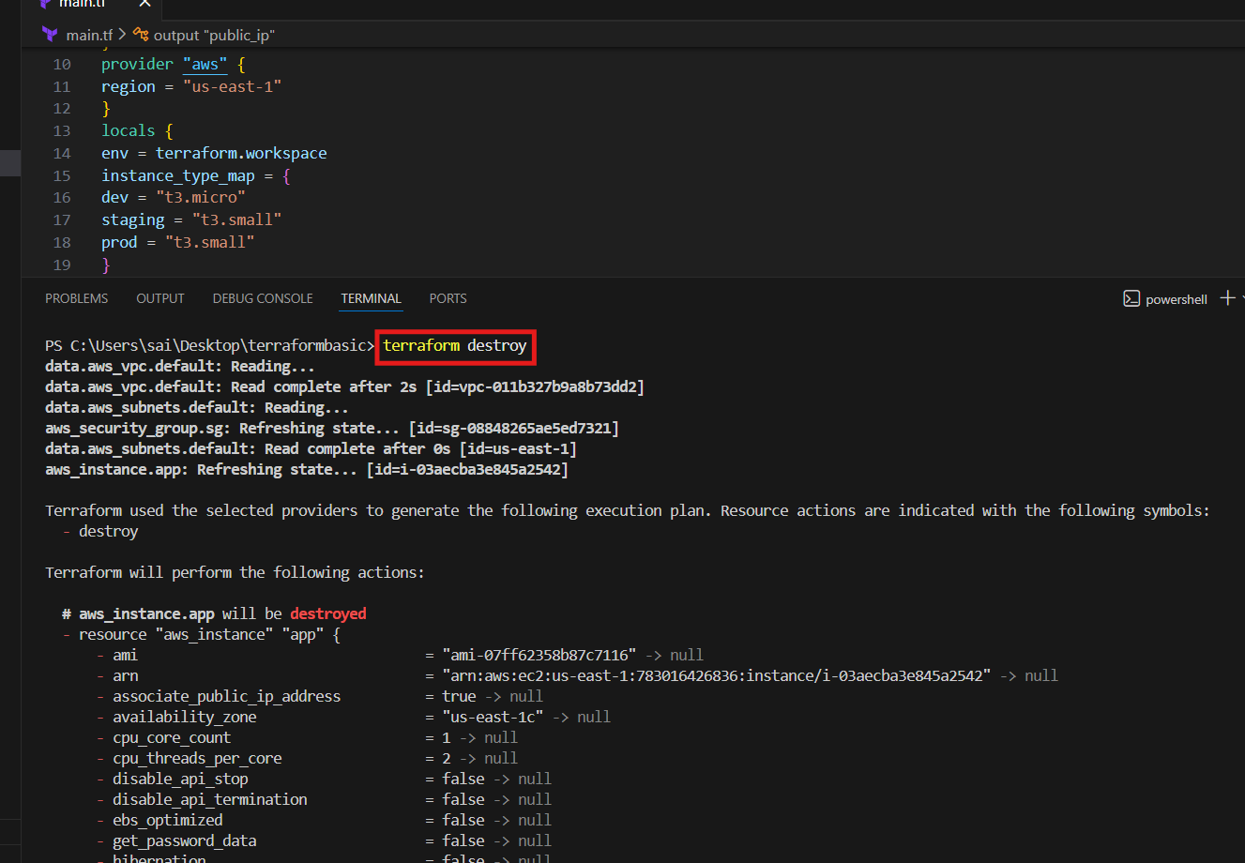
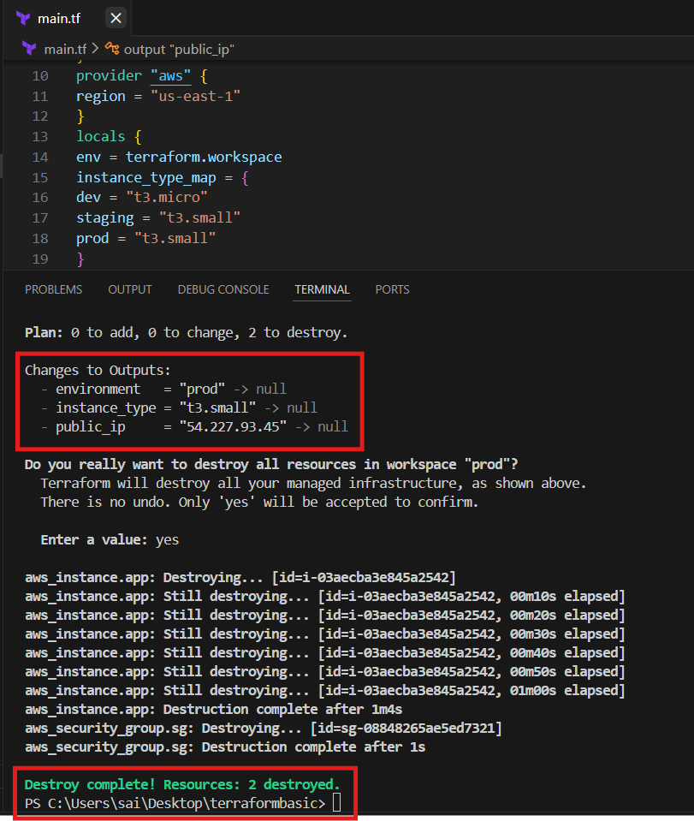
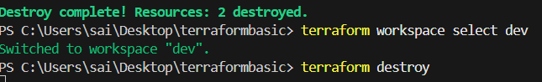
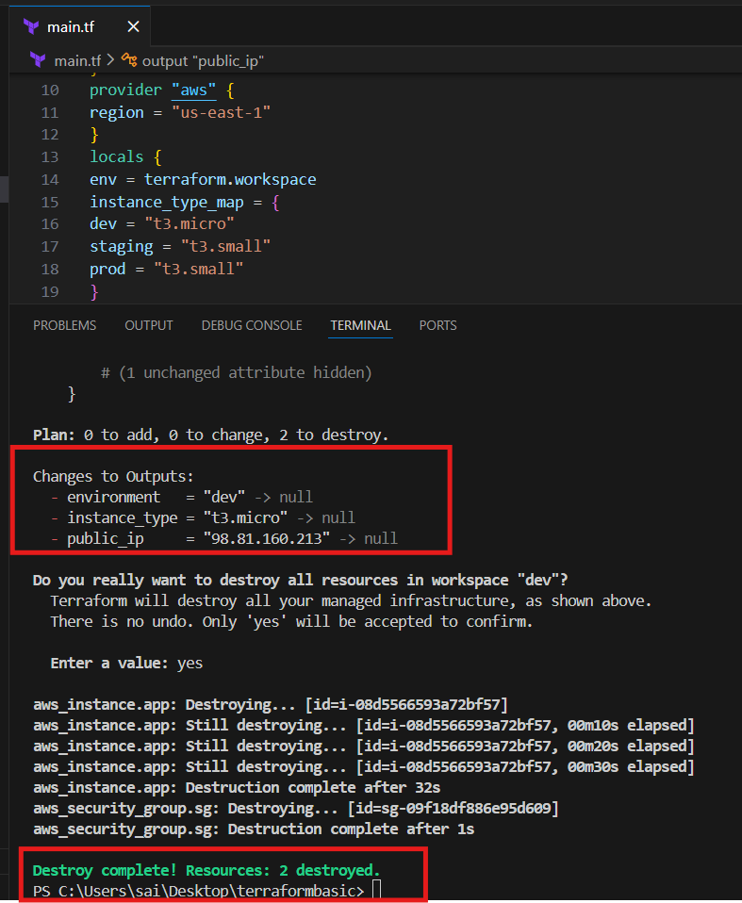
Do the same for staging env

